Explainable Intrusion Detection Systems (X-IDS): A Survey of Current Methods, Challenges, and Opportunities

Abstract and Introduction overlaps with “A Comprehensive Analysis of Explainable AI-Driven Machine Learning Techniques for Network Intrusion Detection Systems”
We will call “A Comprehensive Analysis of Explainable AI-Driven Machine Learning Techniques for Network Intrusion Detection Systems” this as p1 in the whole document now onwards.
EXPLAINABLE ARTIFICIAL INTELLIGENCE (XAI)
- XAI is plagued by inherent challenges that need addressing to foster its development. These include
  - achieving consensus on the right notion of model explainability,
  - identifying and formalizing explainability tasks from the perspectives of various stakeholders
  - designing measures for evaluating explainability techniques (as discussed in p1)
- NOTIONS OF EXPLAINABILITY
  - XAI taxonomies commonly classify explainability based on explanation scope (local vs. global), model dependency (model-specific vs. model-agnostic), data type, explanation methodology, and purpose/usage.
    - Model specific: Explanation method designed around a particular model architecture.
    - Model Agnostic: Can explain different types of models without requiring access to their internal structure
- FORMALIZING EXPLAINABILITY TASKS FROM THE USER PERSPECTIVES
  - This stresses over the part of explainable model to be human comprehensible.
  - This depends on who will receive the explanation (three targets identified: regular user, expert user and external entity)
  - In a medical/legal scenario target is expert user, in a general situation it can be a regular user where chance of developing trust is high.
  - There can be two perspectives: human-like explanation & human friendly explanation.
  - Human like: simulates cognitive process
  - Human friendly: explanation centred on humans
- MEASURES FOR EVALUATING EXPLAINABILITY TECHNIQUES
  - Evaluation can be classified into
    - Application grounded (domain expert)
    - Human grounded(non expert)
    - Functionally grounded (formal metrics)
  - Common quantitative criteria include faithfulness, monotonicity and completeness.
SURVEY AND TAXONOMY
- IDS can be classified as signature based, anomaly based and hybrid.
- Signature based detects known attacks , anomaly based detects unknown/zero day attacks and hybrid utilizes best of both.
- 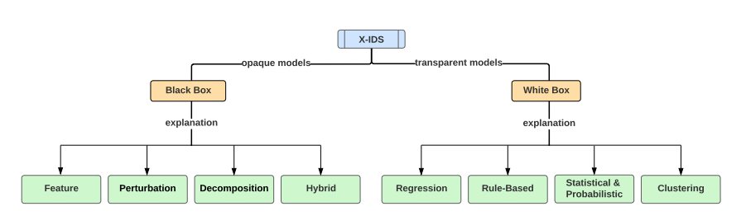
- The above diagram is a taxonomy of white box and black box IDS models.
- NOTE: This paper deeply describes explainability in both black box and white box models. For the sake of our own research we will not go in depth on white box models and rather get a generic idea on it.
- SALIENT FEATURES OF WHITE BOX TECHNIQUES
  - White box models can be interpreted easily due to their decision making process being transparent.
  - The trade off is the predictive performance as compared to neural network based approaches.
  - Main families: regression, clustering, rule based , statistical & probabilistic
- SALIENT FEATURES OF BLACK BOX TECHNIQUES
  - explanations currently fall into four distinct families: Feature, Perturbation, Decomposition, and Hybrid
  - Feature-based: Explain predictions by showing which features contribute most. Examples: SHAP, PDP, ALE, ICE.
  - Perturbation-based: Change/perturb inputs and observe how the prediction changes. Examples: LIME, saliency maps, RISE.
  - Decomposition-based: Break down the model's prediction into contributions from inputs/internal signals. Examples: Integrated Gradients, Grad-CAM, DeepLIFT, LRP.
  - Hybrid-based: Combine multiple models or explanation approaches within a larger ML/IDS pipeline.
APPROACHES TO EXPLAINABLE IDS (X-IDS)
- NOTE: for the sake of our research we will not be getting into White box approaches as well as decomposition based and hybrid based black box approaches.
- BLACK BOX X-IDS MODELS
  - FEATURE BASED APPROACHES
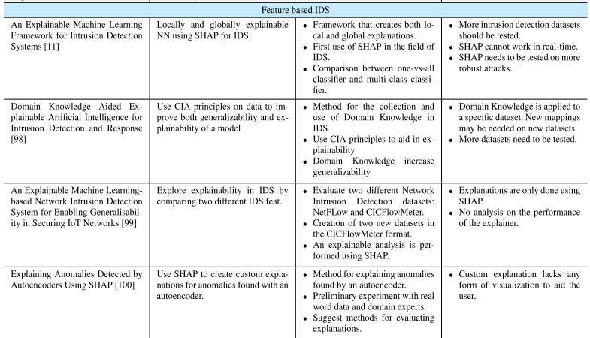
- Shap is dominant here
- Shap is used with neural networks, random forest, XGBoost and autoencoders for both local and global explanations
- SHAP can expose biases in model behavior by showing which features drive prediction (it cannot solve biases)
- Studies are not evaluating explanation quality here aswell (like we saw in p1)
- There is cross dataset explanation instability (this shows that unlike in p1 this paper has gone through cross dataset validation phase)
- This happened because important features varied across datasets due to attack types and feature generation methods (an open issue but not relevant to our research)
- Computational overheads experienced (as happened in p1 but were also overlooked)
- Domain knowledge can make explanations more meaningful that can also help into actionable results (an issue widely mentioned in p1)
  - PERTURBATION BASED APPROACHES
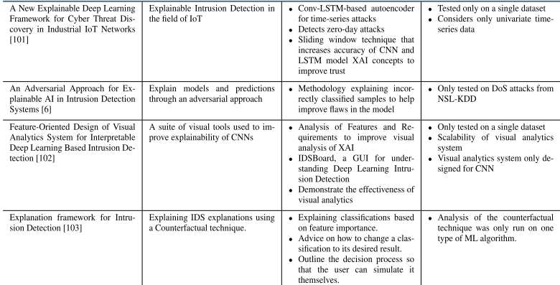
- NOTE:One difference from p1 to note here is that in this paper there is no survey regarding “predictions remaining unchanged but the explanations changing severely as we modify inputs”. This issue was heavily pointed out in p1.
- NOTE: here the research is mainly on how modified inputs can affect prediction performance, something which p1 did not talk about. Generally model agnostic.
- LIME is major perturbation based method in use, can identify the features primarily responsible for individual predictions.
- Counterfactuals can be used to provide actionable explanations by showing what would need to change in input for prediction to change.
- Utilization of counterfactuals: make the smallest changes needed to change an incorrect prediction, then use those changes to explain the misclassification.
- Lack of generalizability, most works have been done on single dataset or specific attack types.
DESIGNING AN EXPLAINABLE IDS (X-IDS)
- Pre modelling phase (raw dataset to high quality data)
  - DATASETS: most commonly used is the NSL-KDD, it is an old dataset. A modern one is CICIDS2017 with up to date attack details. Another notable one is UBR, a multi terabyte dataset. All these are publicly available but not suited for deployable environments.
  - EXPLORATORY DATA ANALYSIS (EDA) AND DATA VISUALIZATION: required to understand key features and characteristics of dataset.
  - FEATURE ENGINEERING: There is a need to reduce dimensions of dataset and hence feature engineering is used
    - Feature selection: reduce the feature space by selecting a subset of features without transforming them.
    - Feature extraction (PCA): reduces the size of the feature space by transforming the original features while retaining most of their defining attributes.
- Modeling phase (high quality dataset to explanations generated by explainer module)
  - AI models: SVM, CNN, RF, MLP, LSTM, GAN ,RNN popular choices
  - EXPLAINER MODULE AND EVALUATION: SHAP, LIME and LRP used. They do not run real time. Another challenge is a standard evaluation metric not yet figured.
- Post modelling phase (explanation interface and users)
  - EXPLANATION INTERFACE: visual dashboards are created to help the user to understand the X-IDS
  - USERS: the stakeholders will consist of developers, defense practitioners, and investors, If an explanation is unclear or unhelpful, the stakeholders will need a way to voice that opinion.
RESEARCH CHALLENGES AND RECOMMENDATIONS
- DEFINING EXPLAINABILITY FOR INTRUSION DETECTION
- DEFINING TASKS AND STAKEHOLDERS
- EVALUATION METRICS
- ADVERSERIAL AI
- MISLEADING/INCORRECT EXPLANATIONS
- SCALABILITY AND PERFORMANCE
(C, D, E stands to be our major focus of interest for the research).

